Exploratory testing of the site <http://www.libertyvan.com/>

The site is using an unsecure protocol (HTTP instead of HTTPS)

**Description:**

The site is using hypertext transfer protocol (HTTP) instead of hypertext transfer protocol secure (HTTPS) which could mean that the customer is not safe while using it.

**Used Device/Browser:**

- Chrome (Version 91.0.4472.77 (64-bit)) on Windows 10

**Steps to reproduce:**

* Open the <http://www.libertyvan.com/> page
* Observe that the URL does not contain HTTPS.
* Observe that the browser is giving you the “Not secure” alert.

**Screenshot:**

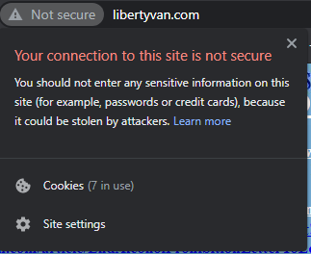

The entire content of the page is not centered

**Description:**

The entire page is aligned to the left, which leaves a third of the page without any content while everything is clustered on the left.

**Used Device/Browser:**

- Chrome (Version 91.0.4472.77 (64-bit)) on Windows 10

**Steps to reproduce:**

* Open the <http://www.libertyvan.com/> page
* Observe that text, links and images are all aligned to the left.
* Observe that the right side is without any content.

**Screenshot:**

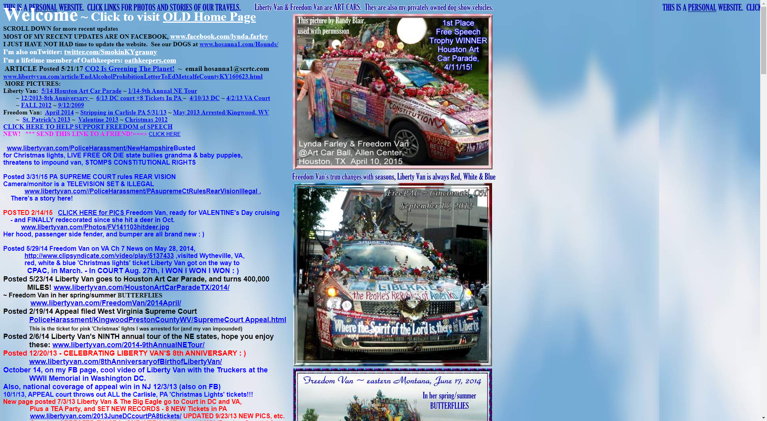

The text in front is overlapping with the text in the background

**Description:**

The “Welcome ~ Click to visit OLD Home Page” heading is overlapping with the text “This is a personal website” in the background. The red text down the page is also overlapping with the blue text in the background.

**Used Device/Browser:**

- Chrome (Version 91.0.4472.77 (64-bit)) on Windows 10

**Steps to reproduce:**

* Open the <http://www.libertyvan.com/> page
* Observe the white Welcome ~ Click to visit OLD Home Page text
* Notice that the text is overlapping with the text “This is a personal website” in the background.
* Scroll down the page and notice that the red text is overlapping with the blue text in the background.

**Screenshot:**

Welcome text overlapping:



Red text overlapping with the blue text:

The background image is not responsive, depending on the window size the image gets repeated or cut off

**Description:**

The background image is not responsive to the size of the window. If the size of the window is too big than the image gets repeated as shown on the first screenshot. And if the window is smaller than only a part of the background image is shown.

**Used Device/Browser:**

- Chrome (Version 91.0.4472.77 (64-bit)) on Windows 10

**Steps to reproduce:**

* Open the <http://www.libertyvan.com/> page
* Observe the background image of the site
* Notice that the text “This is a personal website. Click links for photos and stories of our travels” shown above the white heading is actually a part of the background image and gets repeated again in the top right corner of the page.
* Scroll down the page and notice behind the overlapping red text the same text from the background image mentioned above.
* Notice in the far right that same text.
* Double click the title bar to change the size of the browser window.
* Notice that parts of the background image get cut off and you are unable to horizontally scroll to see the rest.

**Screenshot:**

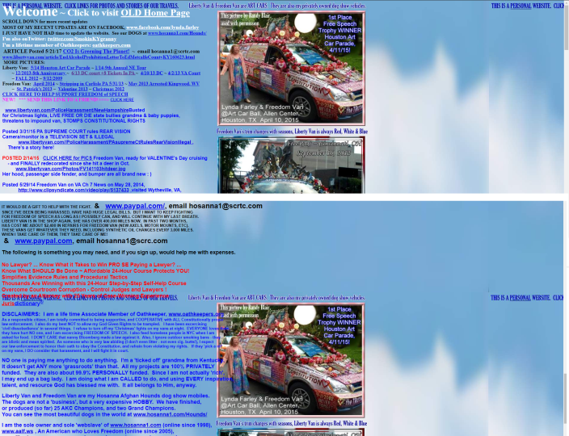 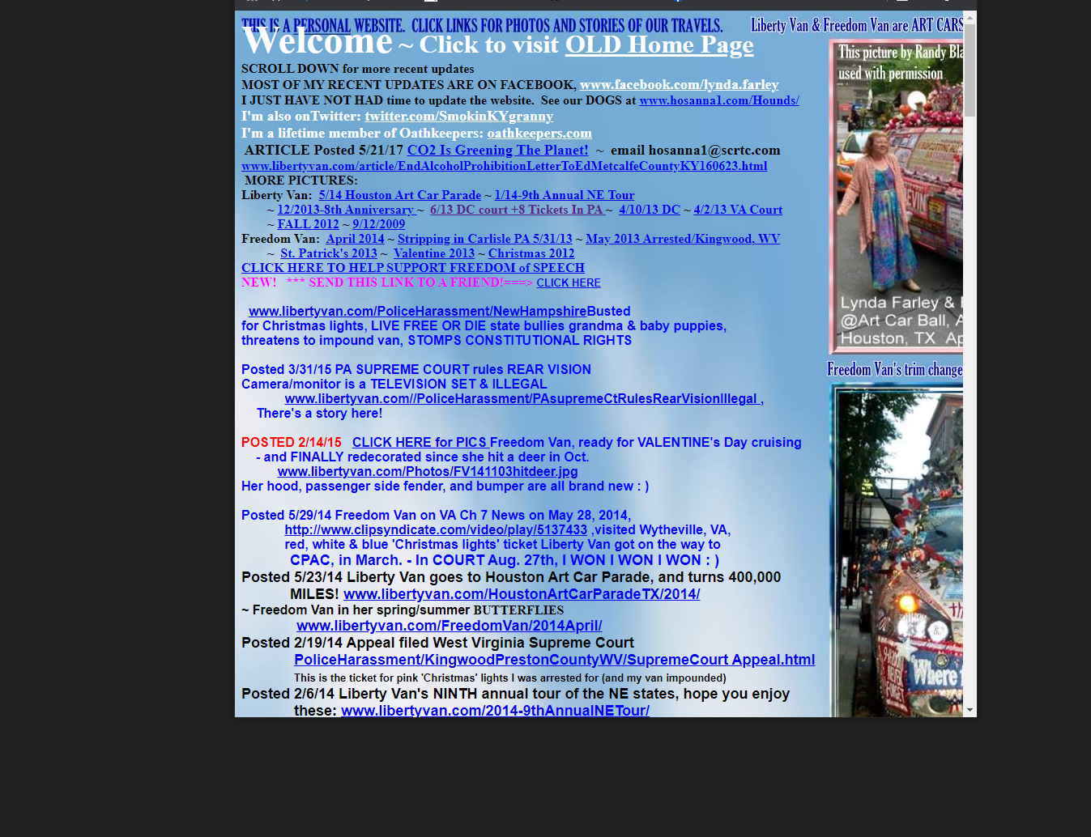

The text goes out of bounds on some places and overlaps with the images

**Description:**

The blue text of the paragraph goes out of bounds and overlaps with the pictures in the center of the page.

**Used Device/Browser:**

- Chrome (Version 91.0.4472.77 (64-bit)) on Windows 10

**Steps to reproduce:**

* Open the <http://www.libertyvan.com/> page
* Scroll down the page
* Notice that the text of some paragraphs goes out of bounds and overlaps with the pictures in the center of the page.

**Screenshot:** 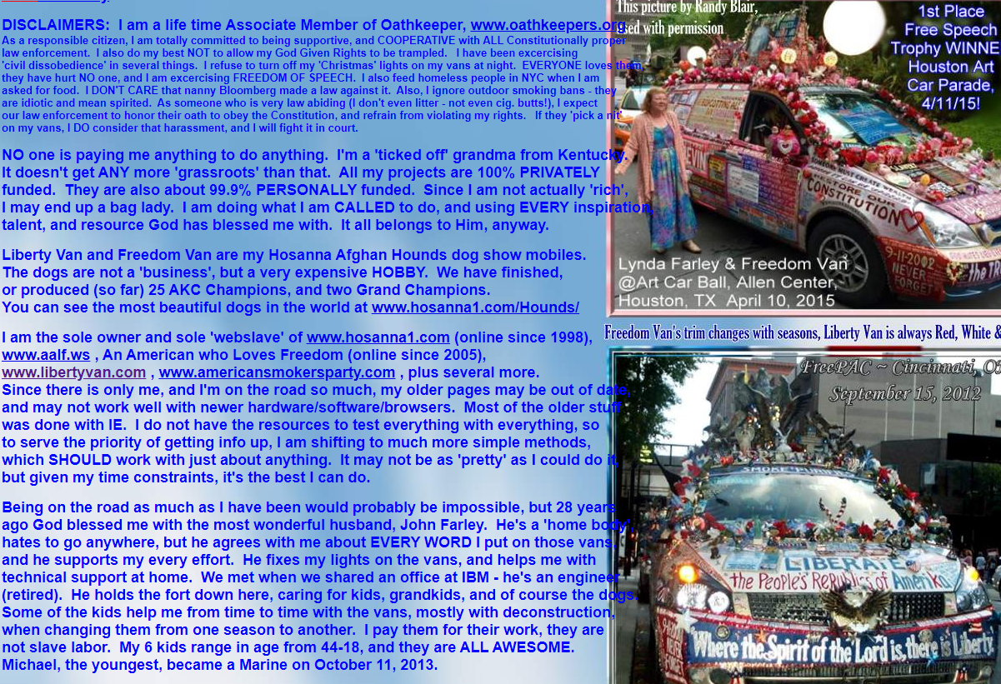

Some parts of the text have low visibility because of the color contrast between the text color and the background color.

**Description:**

As said in the title, some of the paragraphs have the color of the text either too similar to the background or the color contrast makes the text unreadable.

**Used Device/Browser:**

- Chrome (Version 91.0.4472.77 (64-bit)) on Windows 10

**Steps to reproduce:**

* Open the <http://www.libertyvan.com/> page
* Notice the poor readability of the pink text at the end of the first paragraph.
* Scroll down the page
* Notice that the text of some paragraphs has a similar color as the background (blue).
* Continue scrolling the page.
* Notice that the red text has poor readability because of the blue color in the background.

**Screenshots:**

The pink text:

The red text:



The blue text:

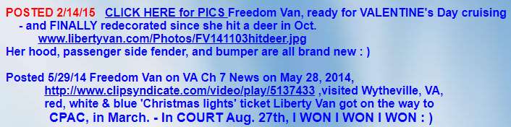

The color of the hyperlinks in some of the paragraphs is the same as the color of the text

**Description:**

The color of the links is the same as the text in most paragraphs, and the only way to distinguish a link from a regular text is the underline under the hyperlinks. Some of the words are underlined but they are not hyperlinks

**Used Device/Browser:**

- Chrome (Version 91.0.4472.77 (64-bit)) on Windows 10

**Steps to reproduce:**

* Open the <http://www.libertyvan.com/> page
* Look at the paragraphs and notice the links in them
* Notice how most of the links have the same color as the text around them.
* Scroll down the page to the end of the Bible quote and try to click the underlined *to stand*
* Notice how this is not a link.

**Screenshots:**

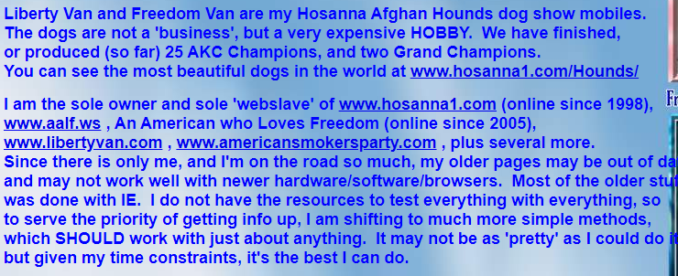

This is not a link:

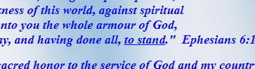

The page is hard to navigate because of poor categorization of paragraphs and different colors and fonts of the text

**Description:**

The page does not effectively or efficiently display its information for viewers and is hard to navigate because of poor categorization of paragraphs. The posts are cluttered together and are hard to understand.

**Used Device/Browser:**

- Chrome (Version 91.0.4472.77 (64-bit)) on Windows 10

**Steps to reproduce:**

* Open the <http://www.libertyvan.com/> page
* Look at the text on the page.
* Notice how different paragraphs are cluttered together without any organization.
* Scroll down the page
* Notice how the color and the font of the text changes from one paragraph to another.

**Screenshots:**

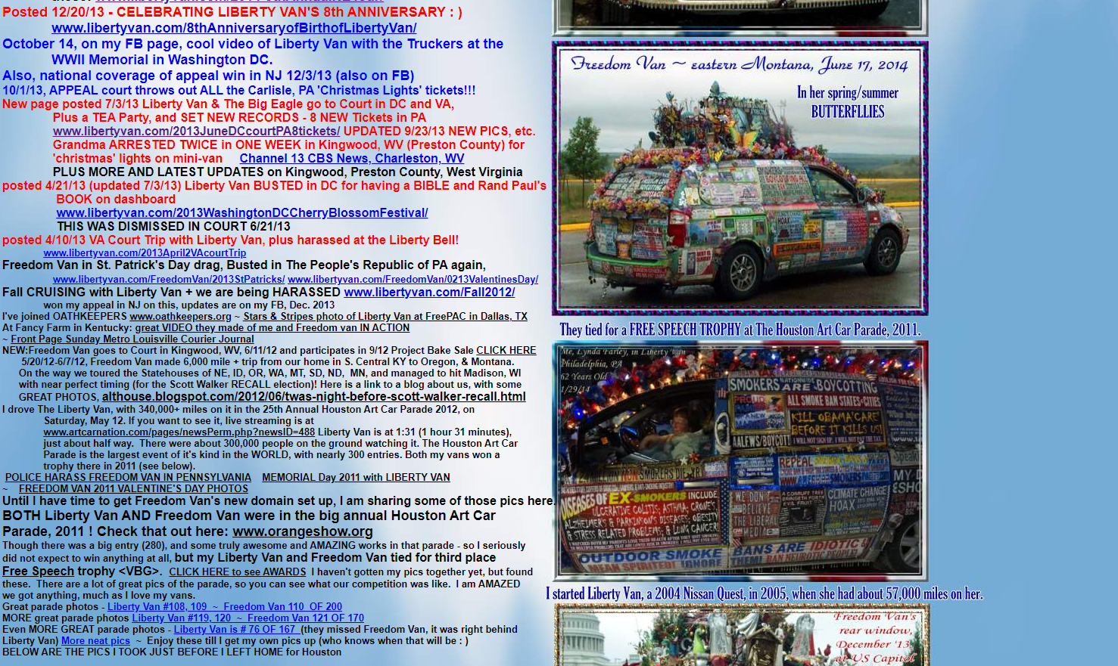

There are too many hyperlinks on the page and it is hard to understand where they lead

**Description:**

The page has too many hyperlinks and most of them have almost no explanation to where they lead.

**Used Device/Browser:**

- Chrome (Version 91.0.4472.77 (64-bit)) on Windows 10

**Steps to reproduce:**

* Open the <http://www.libertyvan.com/> page
* Look at the underlined hyperlinks on the page.
* Notice how they are mostly all over the place without any organization.
* Continue looking and reading the links while slowly scrolling the page.
* Observe that the little explanation that you get is mostly in the link itself but since there are too many it gets confusing very quickly.

**Screenshots:**

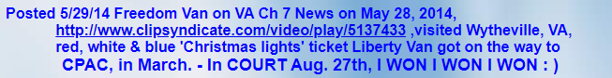

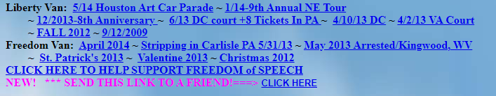



Some of the links on the page are expired links but they are not updated or deleted

**Description:**

Some of the links on the page no longer work, but are not updated or deleted.

**Used Device/Browser:**

- Chrome (Version 91.0.4472.77 (64-bit)) on Windows 10

**Steps to reproduce:**

* Open the <http://www.libertyvan.com/> page
* Scroll down and find the below mentioned hyperlinks on the page.
* If you click any of the links mentioned underneath they will lead you to the error page

**The links that no longer work: (**The black text is the text from the site, the blue is the actual URL**)**

<http://www.clipsyndicate.com/video/play/5137433>

great VIDEO they made of me and Freedom van IN ACTION (https://www.courier-journal.com/errors/404/)

www.artcarnation.com/pages/newsPerm.php?newsID=488

CLICK HERE to see AWARDS (<https://www.orangeshow.org/Art-Car/2011-Awards>)

Liberty Van is # 76 OF 167 (https://www.facebook.com/photo.php?fbid=1737912015407&set=a.1737892854928.2087293.1466835851&type=1&pid=2936926&id=1466835851#!/photo.php?fbid=1737953896454&set=a.1737892854928.2087293.1466835851&type=1&pid=2937027&id=1466835851)

**Screenshots:**

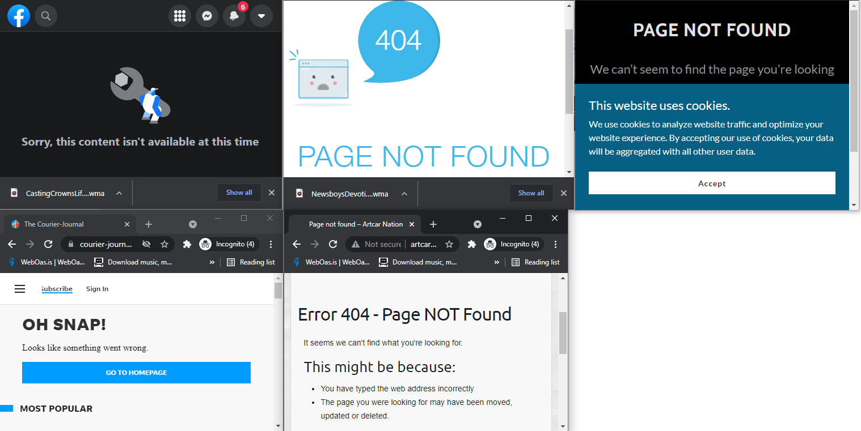

Some of the links are downloading files even though there is no indication that those are download links.

**Description:**

Some of the links when clicked download a file to our local machine even though there is no indication that this will happen.

**Used Device/Browser:**

- Chrome (Version 91.0.4472.77 (64-bit)) on Windows 10

**Steps to reproduce:**

* Open the <http://www.libertyvan.com/> page
* Find and click any of the down mentioned links.
* Observe how the links download a word file to your PC.
* Scroll through the page and find one of the links that download the music files and click them.
* Notice how the link takes you to the new page, but also downloads a music file to your PC
* Those are the remnants of the old music auto-play after entering a site that should be removed.

**Screenshots:**

[**EVERYONE PAYS TOBACCO TAXES**](http://www.libertyvan.com/Flyers/FLYER-TobaccoTaxesHurtEconomy.doc)

[**WHY we are in BIG TROUBLE: Americanism VS Communism**](http://www.libertyvan.com/Flyers/FLYERIndependenceDayTheCommunistManifesto.doc)

[**www.americansmokersparty.com/Flyers/NewYearResolutions.doc**](http://www.americansmokersparty.com/Flyers/NewYearResolutions.doc)

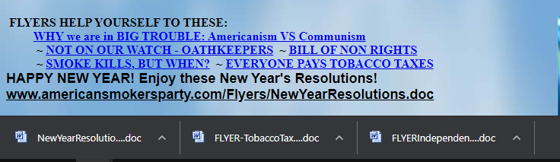

Below are the links that download music files to the pc:

[**Stripping in Carlisle PA 5/31/13**](http://www.libertyvan.com/PoliceHarassment/strippingFreedomVan/)**~**[**May 2013 Arrested/Kingwood, WV ~**[**Valentine 2013**](http://www.libertyvan.com/FreedomVan/0213ValentinesDay/)**~**[**Christmas 2012**](http://www.libertyvan.com/FreedomVan/2012Christmas/)](http://www.libertyvan.com/PoliceHarassment/KingwoodPrestonCountyWV/ArrestedTwice/index.html) 